Keep it simple but successful with this quick resume template.

 | INSERT NAME
CONTACT |  |  |  |  | SUMMARY/OBJECTIVE
 |  | +61 (0)412 123456 |  |  | A summary statement is 2-3 sentences that provides a brief synopsis of your work experience and skills. This is your opportunity to showcase yourself and demonstrate how you can benefit your employer and sets you apart from other experienced candidates.
 |  | example@gmail.com
 |  | Insert your city location
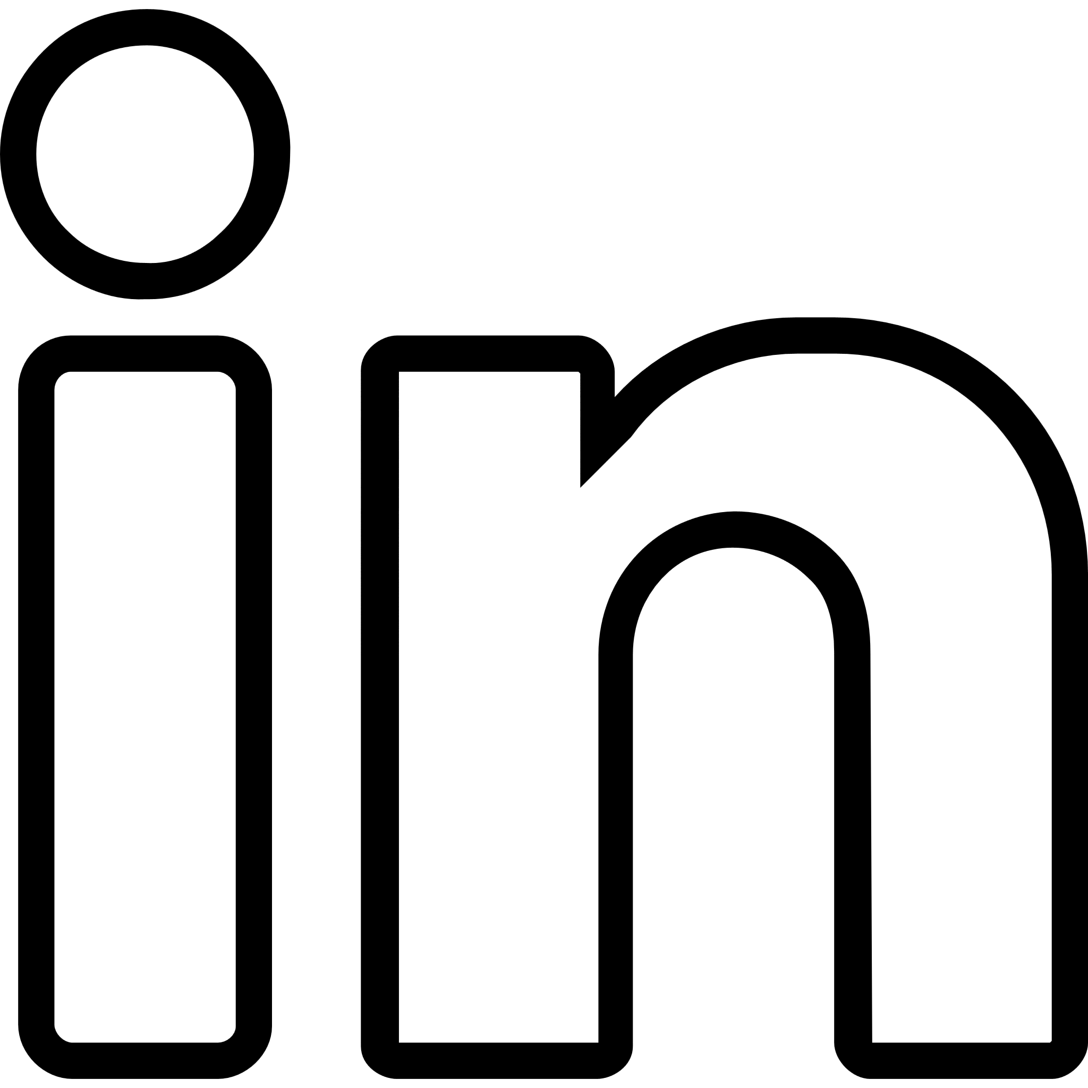 |  | LinkedIn profile link where available.
EDUCATION |  |  |  |  | WORK EXPERIENCE
Name of School: (If you have a college degree, don’t include a high school diploma)  Degree earned:  Years attended:  City, State: |  |  |  |  | WRITE YOUR JOB TITLE HERE  Company Name | Location | 20XX – Present | Hours of work per week  - Outline the key responsibilities and duties of your role.  - Outline your key contributions.  - Outline key achievements.  WRITE YOUR JOB TITLE HERE  Company Name | Location | 20XX – Present | Hours of work per week  - Keep your bullet point descriptions at three lines or under. Write your job descriptions in the past tense, though you can write current experience in the present tense if you wish.
SKILLS
- Include 6 to 8 skills, no more than 10
- Highlight and detail your coaching skills.
- Soft skills: not easy to measure - like ‘communication’, ‘teamwork’, ‘adaptability’ etc.
- Include "keywords," skills you find mentioned in the job advert.
Be honest; exaggerating your abilities will eventually be found out
Make sure your skills are represented in your work experience
INTERESTS |  |  |  |  | TENNIS/SPORTS CERTIFICATIONS/LICENSES
Only include interests if you can explain their relevance to the job and if they demonstrate alignment with a company's culture and values. |  |  |  |  | Be sure to stay on top of this as certifications and licenses can differ between countries/states and even across jobs in the same industry.

